**Assignment No-1**

1. Armstrong Number

Problem: Write a Java program to check if a given number is an Armstrong number.

**package** org.assignment.ADS;

**import** java.util.Scanner;

**public** **class** Prg1 {

**public** **static** **void** main(String[] args) {

Scanner sc=**new** Scanner(System.***in***);

System.***out***.println("Enter a Number:");

**int** n1=sc.nextInt();

**int** result=0,rem;

**int** num2=n1;

**while**(n1>0)

{

rem=n1%10;

result=result+(rem*rem*rem);

n1=n1/10;

}

**if**(num2==result)

{

System.***out***.println(result+" Is Armstrong Number");

}

**else**

System.***out***.println(result+" Is not Armstrong Number");

}}

Flowchart:

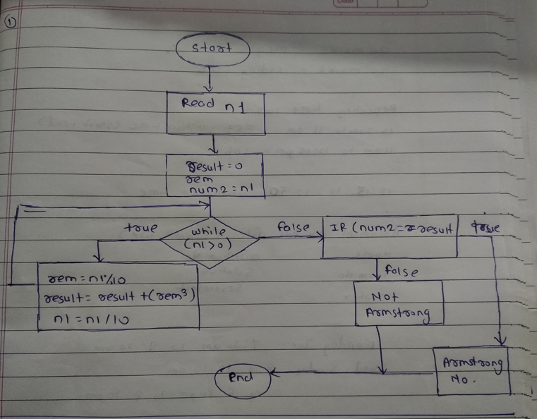

**Explanation:**

First take input from user. Set result as 0, declared rem and store value of enter number in another variable then check condition if given number greater than 0 then perform some operation and then compare result and stored value if it is true then number is “Armstrong” number.

**Output:**

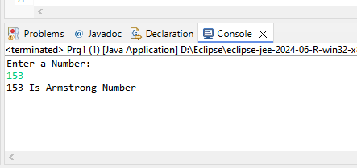

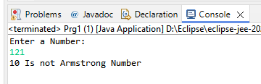

2. Prime Number

Problem: Write a Java program to check if a given number is prime.

**package** org.assignment.ADS;

**import** java.util.Scanner;

**public** **class** Prg2 {

**public** **static** **void** main(String[] args) {

Scanner sc=**new** Scanner(System.***in***);

System.***out***.println("Enter a number:");

**int** num=sc.nextInt();

**boolean** flag=**false**;

**if**(num==0|num==1)

flag=**true**;

**for**(**int** i=2;i<=num/2;i++)

{

**if**(num%i==0)

flag=**true**;

**break**;

}

**if**(!flag)

System.***out***.println(num+" is Prime Number");

**else**

System.***out***.println(num+" is not Prime Number");

}

}

Flowchart:

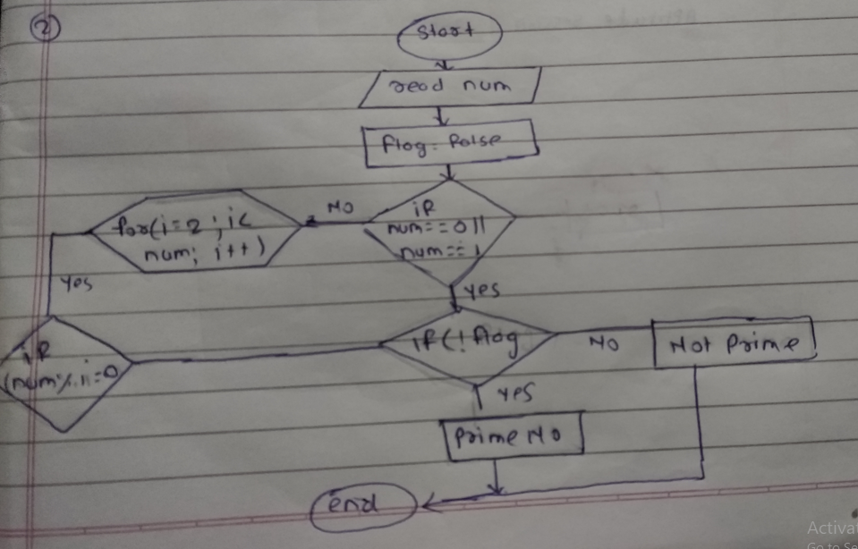

**Explanation:**

In this program take input from user. Check condition if num is equal to 0 or 1 then it true then use loop and check number is prime or not.

**Output:**

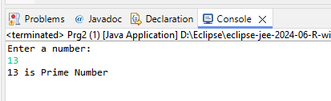

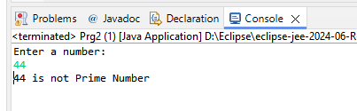

3. Factorial

Problem: Write a Java program to compute the factorial of a given number.

**package** org.assignment.ADS;

**import** java.util.Scanner;

**public** **class** Prg3 {

**public** **static** **void** main(String[] args) {

Scanner sc=**new** Scanner(System.***in***);

System.***out***.println("Enter a Number:");

**int** num=sc.nextInt();

**int** res=1;

**for**(**int** i=2;i<=num;i++)

{

res=res*i;

}

System.***out***.println(num+" Factorial is:"+res);

}

}

Flowchart:

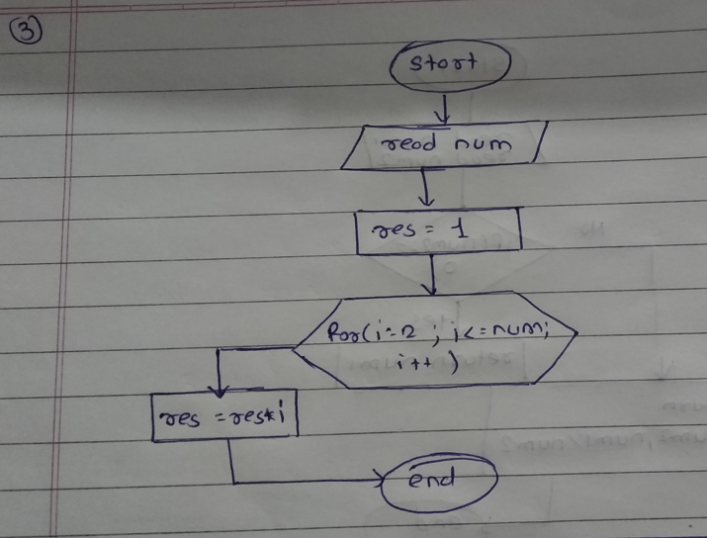

**Explanation:**

In this program take input from user set res is one then using for loop chek codtion and perform operation and then print result.

**Output:**

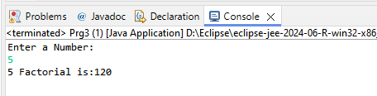

4. Fibonacci Series

Problem: Write a Java program to print the first n numbers in the Fibonacci series.

**package** org.assignment.ADS;

**import** java.util.Scanner;

**public** **class** Prg4 {

**public** **static** **void** main(String[] args) {

Scanner sc=**new** Scanner(System.***in***);

System.***out***.println("Enter a Number:");

**int** num=sc.nextInt();

**int** num1=0,num2=1;

**int** sum = 0;

System.***out***.println("Fibonaci Series:");

**for**(**int** i=0;i<num;i++)

{

System.***out***.print(num1+" ");

**int** num3=num1+num2;

num1=num2;

num2=num3;

}

}

}

Flowchart:

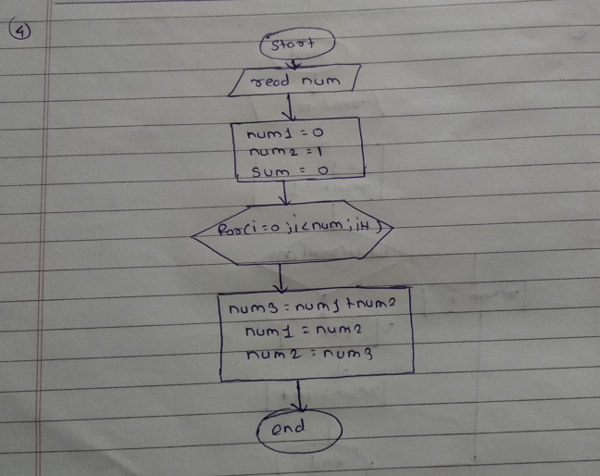

**Explanation:**

In this program take input from user set num1,num2 as 0 nd 1 set sum is 0 using for loop check condition if true then swap in value.

**Output:**

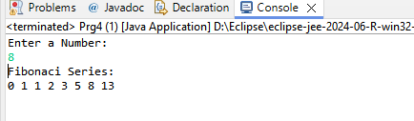

5. Find GCD

Problem: Write a Java program to find the Greatest Common Divisor (GCD) of two numbers.

Program:

**package** org.assignment.ADS;

**import** java.util.Scanner;

**public** **class** Prg5 {

**private** **static** **int** gcd(**int** n1, **int** n2) {

**if**(n2==0)

**return** n1;

**return** *gcd*(n2,n1%n2);

}

**public** **static** **void** main(String[] args) {

Scanner sc=**new** Scanner(System.***in***);

System.***out***.println("Enter Two Number:");

**int** n1=sc.nextInt();

**int** n2=sc.nextInt();

System.***out***.println("GCD:"+*gcd*(n1,n2));

}

}

Flowchart

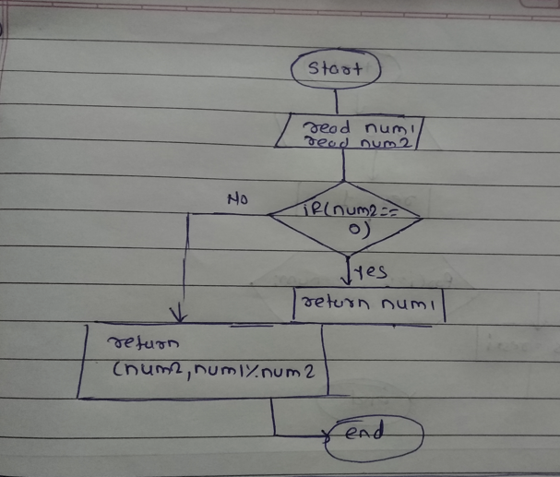

**Explanation**

Take two number from user and pass it to function in that funtion check if n2 is equla to 0 then it return n1 otherwise reursion perform.

**Output:**

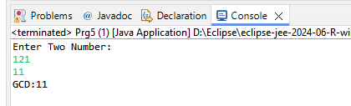

6. Find Square Root

Problem: Write a Java program to find the square root of a given number (using integer approximation).

**package** org.assignment.ADS;

**import** java.util.Scanner;

**public** **class** Prg6 {

**static** **int** Sqrt(**int** x)

{

**if** (x == 0 || x == 1)

**return** x;

**int** i = 1, result = 1;

**while** (result < x) {

i++;

result = i * i;

}

**return** i ;

}

**public** **static** **void** main(String[] args)

{

Scanner sc=**new** Scanner(System.***in***);

System.***out***.println("Enter a number:");

**int** x = sc.nextInt();

System.***out***.print("Square Root:"+*Sqrt*(x));

}

}

Flowchart:

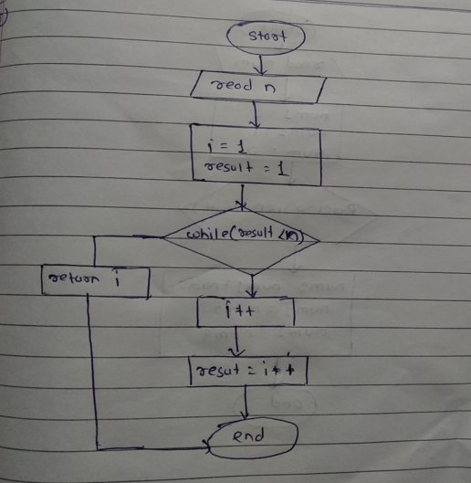

**Explanation**

Take number from user chek number is 0 or 1 it is 0 or 1 then return that number.then set I=1 and result=1 using while condition check result is less than num or not if true then increment I and perform result=i*I.

**Output:**

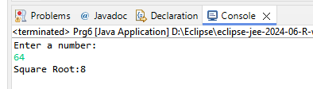

7. Find Repeated Characters in a String

Problem: Write a Java program to find all repeated characters in a string.

**package** org.assignment.ADS;

**import** java.util.Scanner;

**public** **class** Prg7 {

**private** **static** **void** findRepeat(String str) {

**char**[] c=str.toCharArray();

System.***out***.println("Repeated Character:");

**for**(**int** i=0;i<str.length();i++) {

**for**(**int** j=i+1;j<str.length();j++)

{

**if**(c[i]==c[j])

{

System.***out***.print(c[j]+" ");

}

}

}

}

**public** **static** **void** main(String[] args) {

Scanner sc=**new** Scanner(System.***in***);

System.***out***.println("Enter a String:");

String str=sc.nextLine();

*findRepeat*(str);

}

}

Flowchart:

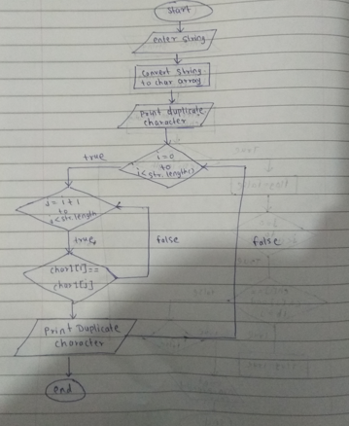

**Explanation:**

Take string input from user conver string to char using toCharArray use to for loop and check if char[I]==char[j] then stored value in char[j] and print it

**Output:**

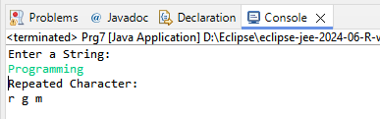

8. First Non-Repeated Character

Problem: Write a Java program to find the first non-repeated character in a string.

**package** org.assignment.ADS;

**import** java.util.Scanner;

**public** **class** Prg8 {

**private** **static** **void** nonRepeat(String str)

{

**char**[] c=str.toCharArray();

System.***out***.println("Non-Repeated Character:");

**for**(**int** i=0;i<str.length();i++) {

**boolean** flag=**false**;

**for**(**int** j=0;j<str.length();j++)

{

**if** (i != j && c[i] == c[j])

{

flag = **true**;

**break**;

}

}

**if**(!flag)

{

System.***out***.print(c[i]+" ");

}

}

}

**public** **static** **void** main(String[] args) {

Scanner sc=**new** Scanner(System.***in***);

System.***out***.println("Enter a String:");

String str=sc.nextLine();

*nonRepeat*(str);

}

}

Flowchart:

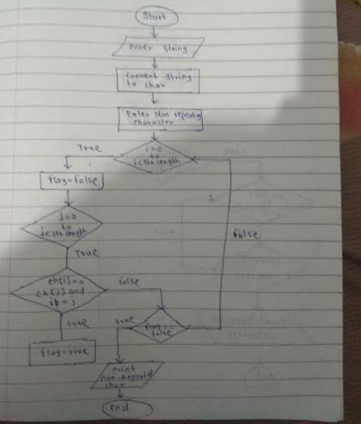

**Output:**

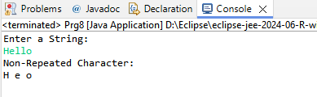

9. Integer Palindrome

Problem: Write a Java program to check if a given integer is a palindrome.

**package** org.assignment.ADS;

**import** java.util.Scanner;

**public** **class** Prg9 {

**public** **static** **void** main(String[] args) {

Scanner sc=**new** Scanner(System.***in***);

System.***out***.println("Enter a number:");

**int** n1=sc.nextInt();

**int** result=n1;

**int** rem,res = 0;

**while**(n1>0)

{

rem=n1%10;

res=res*10+rem;

n1=n1/10;

}

**if**(result==res)

{

System.***out***.println("Palindrome");

}

**else**

{

System.***out***.println("Not Palindrome");

}

}

}

Flowchart:

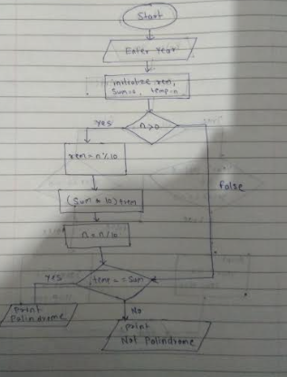

**Explanation**

Take number from user set value of res=0, declare rem and store input to another variable check while condition n1>0 it true then perform some operation and then check if res is equal to enter number then palindrome.

**Output:**

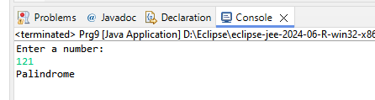

10. Leap Year

Problem: Write a Java program to check if a given year is a leap year.

**package** org.assignment.ADS;

**import** java.util.Scanner;

**public** **class** Prg10 {

**public** **static** **void** main(String[] args) {

**int** y;

Scanner sc=**new** Scanner(System.***in***);

System.***out***.println("Enter Year:");

y=sc.nextInt();

**if**(y%4==0)

{

System.***out***.println(y+" "+"Leap Year");

}

**else** **if**(y%100==0 && y%400==0)

{

System.***out***.println(y+" "+"Leap Year");

}

**else**

{

System.***out***.println(y+" "+"Not Leap Year");

}

}

}

Flowchart:

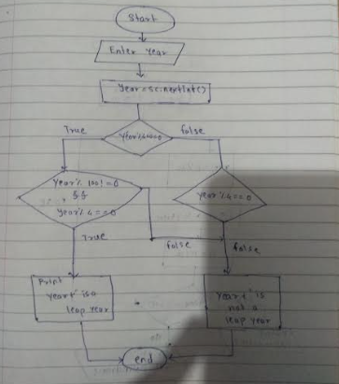

**Output:**

